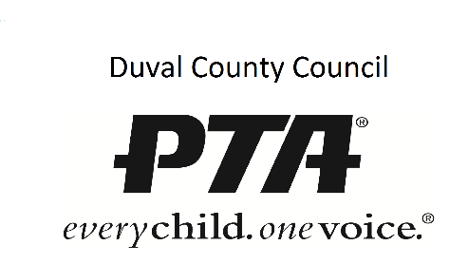
SMART Goal Help Worksheet
Richard Godke - rgodke@yahoo.com - DCCPTA Leadership Training June 16, 2016
Team or Organization:
Name(s):
Date:

 | What do you want to achieve?
SPECIFIC | Who?  What?  Why?  Where?  When?
Measurable | How Much?  How often?  How many?
Attainable | Achievable?
Relevant | Is it important to what you want to achieve ultimately?
Time Based | When
 | Restate the goal
Ag Info Design LLC O5.23.16 ©

