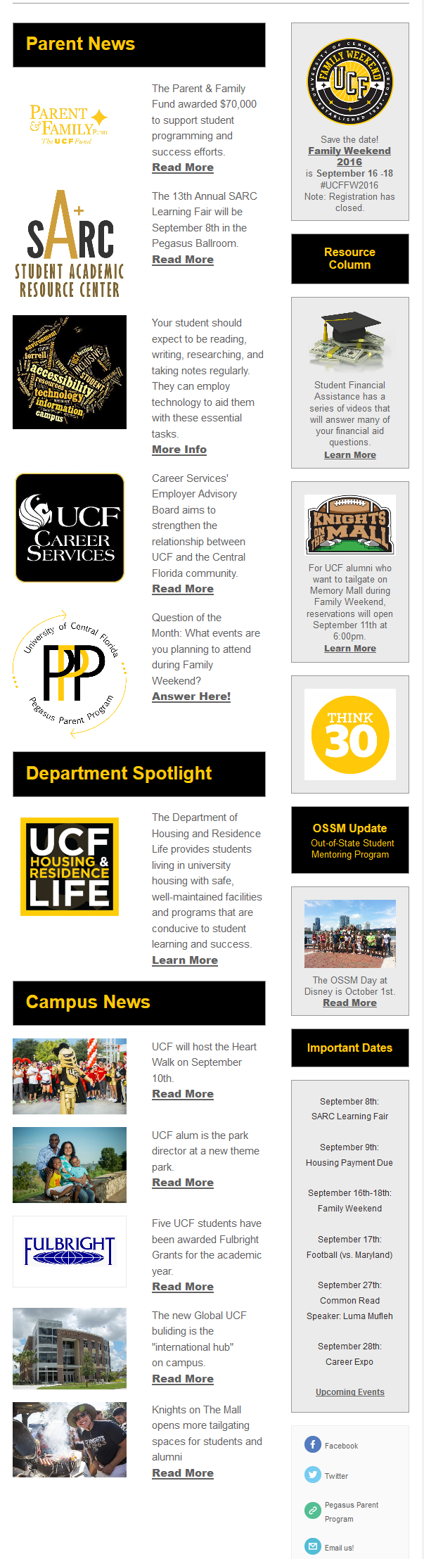

This is an example of a newsletter that has short articles that refer back to the website